
E.O. Bull Center

2 E. Rosedale Avenue
Built: 1968 | Size: 49,849 sf
Acquired: N/A | Condition: Fair
Last Renovation: | Function: E&G

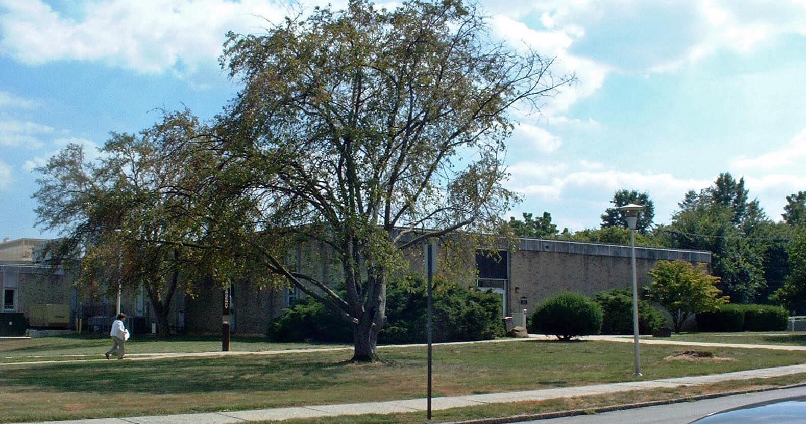

The E.O. Bull Center marks the southeast corner of Rosedale Avenue and High Street. This building is located at the main vehicular entrance to the University campus and adjacent to the newly constructed Swope Music Building and the Performing Arts Center. It is a hub of activity for the University, currently housing the main computing center for the University, as well as the administrative computing offices; the newly-constructed Student Services Center (Bursar, Financial Aid and Registrar Offices); the TV and Radio Studio; the Theater Department; and the Main Stage Theater.

Future plans include the consolidation of the new College of Visual & Theatre Arts into this building, featuring the Dance & Art Departments, and the relocation of the current IT Department and Student Services Departments to another campus locations.

Present Use: Administrative computing, administrative offices, Theater Department, Bursar, Registrar, Financial Aid, and Theatre faculty offices and classrooms.

Disability Access: Full, from entrances on both floors. Elevator does not easily accommodate wheelchairs.

Past Projects: 1993/1995 HVAC, 1994 Main Stage Theatre Improvements, 1997- Bursar’s Office, 1998- Theatre Lighting Grid, 2000 Black Box Theatre, 2001 Roof, 2003 Emerg generator, J Peter Adler Theatre 2005.

Scheduled Projects or Capital Renovations: 2008- life-cycle Capital Renovation.

Description of Construction: Reinforced concrete foundations, built-up roof, masonry brick veneer exterior walls, concrete slab floors.

Condition and Use Assessment:
Deferred Maintenance (2007): $ 1,782,000 | Est Replacement Cost (2007): $ 12,240,000
Facility Condition Index: 0.15 | Deficiency/SF: $ 35.74
Yearly Electric Use Cost: $ | Yearly Water Use Cost $

