Advising WCU Student Athletes: Special Considerations
Over 600 student-athletes depend on you for advice as the navigate the complexities not only of WCU but of NCAA regulations Aside from meeting all requirements for graduation from their individual major, student-athletes must meet academic benchmarks in order to be academically eligible to compete in National Collegiate Athletic Association (NCAA) Sports. When advising student-athletes on what courses to take, it is important to review the NCAA requirements as well as university requirements.

Unique circumstances!
- Student-Athletes participate in 20 hours per week of athletic activity. Many also receive necessary medical treatment related to their sport, participate in community service with their team, attend outside meetings pertaining to athletics or attend personal development workshops.
- Student-Athletes also travel to compete in their sport and represent the university. Depending on the sport, this could happen several times per week. Students should attempt to use their priority scheduling ability to schedule classes that do not conflict with practices and games.
Resources!
- We are proud to announce that we are able to offer academic assistance to many of our student-athletes. Our Academic Mentoring Program is overseen by Dr. Tammy James and employs five graduate assistants who work with 70-80 student-athletes.
- Our Student-Athlete Support Services Program offers Academic Success Workshops during the Athlete-only study hall.
  - However, these resources may not reach all of our 600 student-athletes, and they may need outside assistance.
- YOU, their academic advisor! Please help them:
  - Meet with you early in the advising season so they can take advantage of priority scheduling.
  - Communicate with their coach or with Dr. Tammy James if you have questions about their eligibility status or special needs.
  - Realize the increased pressures on student-athletes. They may be juggling a complex schedule and may not yet have the time management skills students develop over their college careers. They may struggle with performance in their sport as well as in the classroom. And they may have personal difficulties that may loom large for them because of the complexity of their schedule.
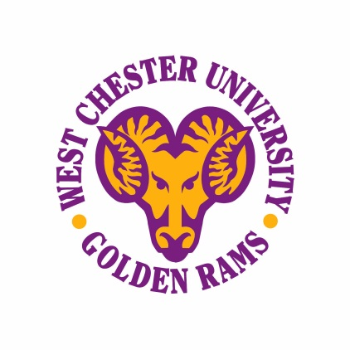

NCAA Rules: Progress Toward Degree Requirements
NCAA Bylaw 14.4.1: “To be eligible to represent an institution in intercollegiate athletics competition, a student-athlete shall maintain progress toward a baccalaureate or equivalent degree at that institution.”
- Good Academic Standing: Students must be in good academic standing per the university. For student-athletes at WCU who may be on probation, Good Academic Standing is determined by their participation in the Academic Mentoring Program and developing an ARP.
- Term-by-term Credit Hour Requirement: Students must pass at least nine credits in the previous term to be eligible for the following term. These credits must be toward the student’s degree program after the fifth semester.
- Credit Hours Earned During the Regular Academic Year: Students must complete 18 hours since the beginning of the fall term, during the regular academic year (not summer).
- Annual Credit Hour Requirement: Students must earn 24 hours during any year they were enrolled full time in at least one academic term. Students may earn 48 credits during their first two years of enrollment to meet this requirement.
- Fulfillment of Minimum Grade-Point Average: Students must achieve a cumulative minimum grade point average of 2.0 prior to each fall term.
- Designation of Degree Program: Students must declare a major by the third year or fifth semester.
Rules that should be taken into consideration before scheduling classes:
- Remedial or non-credit courses:
  - Must be considered to be prerequisites for specific courses acceptable for any degree program.
  - Must be given the same weight in determining status for full-time enrollment.
  - Credit in such courses shall not exceed 12 semester hours, and the courses must be taken during the student’s first academic year of collegiate enrollment (to be used for NCAA eligibility).
- Classes for minor:
  - Should a student declare a minor, after his or her third year, only six credits per term may be used for eligibility purposes that are for that minor. All other classes should be for the major.
- Repeated courses:
  - A course repeated due to an unsatisfactory initial grade may be used only once and only after it has been satisfactorily completed.
  - Credit for a course that may be taken several times shall be limited by institutional regulations.
  - If a student passes a class and re-takes it, the first class passed will be used for eligibility purposes. Courses cannot be used twice for eligibility purposes.
- Failed courses:
  - If a student fails a class, it is NOT used for eligibility purposes and will be used when it is passed.

