Campus Labs Benchmarking Tool
- An easy way to build multi-project comparison reports (e.g., for surveys you conduct every semester/year or when you want to compare pre- and post-rubrics)
- Works best for quantitative questions, not open-ended qualitative responses.
- To compare two or more surveys or projects, the projects much share identical questions for comparison.
- To compare two or more projects, you must ask Campus Labs staff to “benchmark” the relevant projects so you can access them in the Benchmarks tool. (e.g., “I conduct this same survey every year at the same time. Can you please benchmark this survey with the previous two surveys so I can generate a 3-year comparison report?”)

Steps for creating a benchmarked report

Log into your Campus Labs Baseline account:
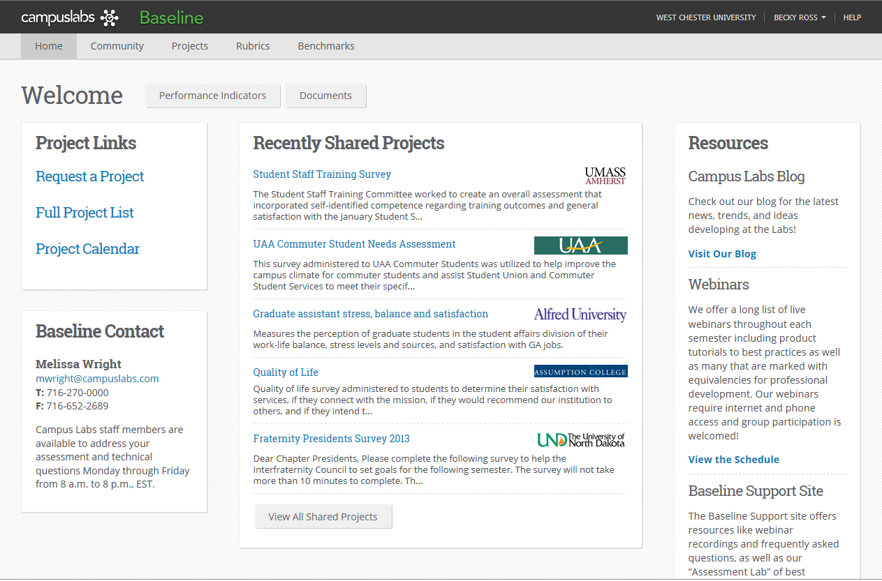

Click on Benchmarks menu item at the top of the page:
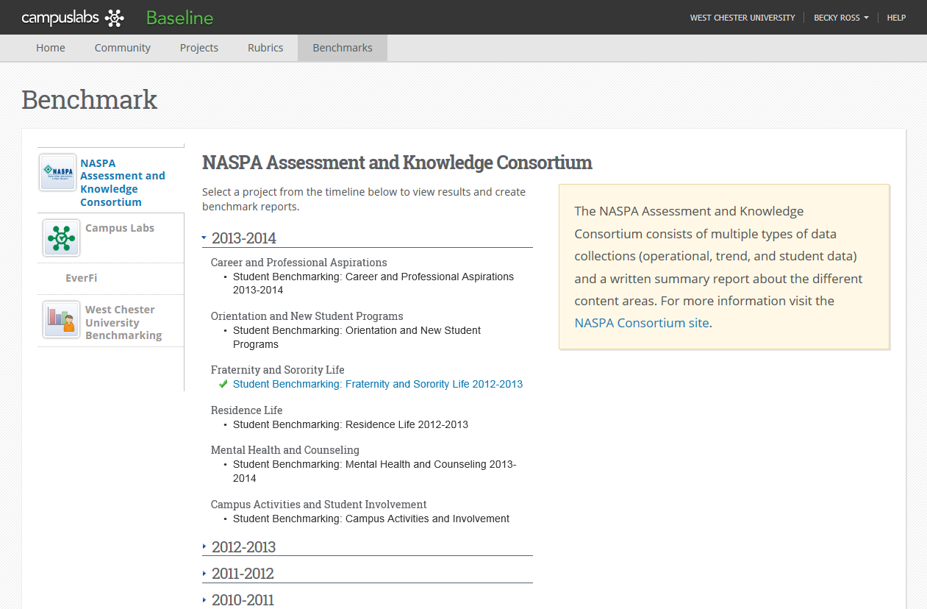

Click on West Chester University Benchmarking on the left-hand menu
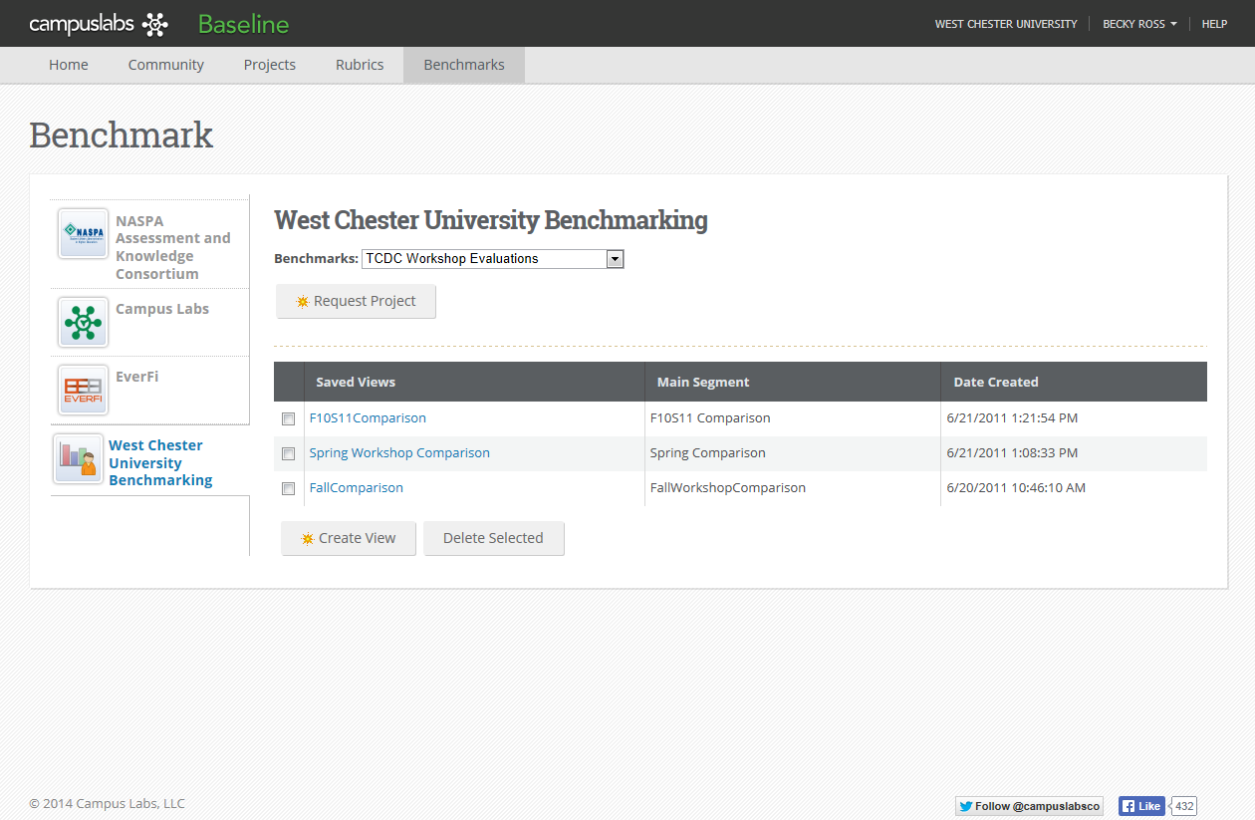

Use drop-down menu to select your benchmarked surveys (you will create this name with Campus Labs when you first request that projects be benchmarked; you will also see other offices’ projects in this list, they will not all be your projects)

The “Saved Views” are reports that you have previously created.

Click Create View to create a new report – page one is a brief overview of the report wizard that guides you through creating a comparison report:
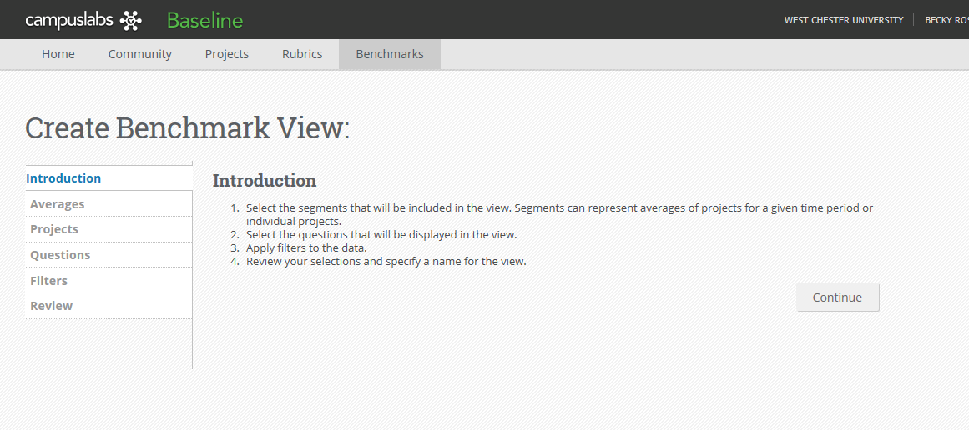

Click Continue to go to the next step.

Select Average Segments – this screen lets you select all of the projects you want to include in the comparison report and lets you set up/calculate the average value for all included projects (e.g., if you are including 3 surveys from 3 years, this section lets you select all projects and then a 3-year average)

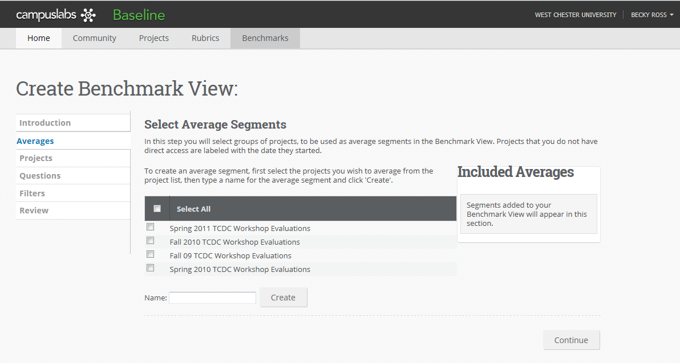

To compare the Spring 2010 Workshop Evaluations and the Spring 2011 Workshop Evaluations, select those two projects and Name this something like “Spring Evaluation Average” – this will appear in your comparison report as the combined average score from all the projects you include.
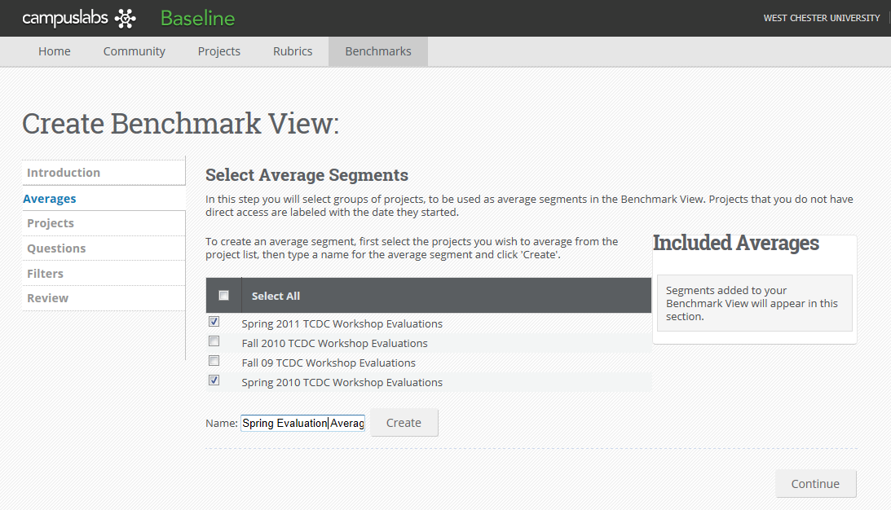

Click the Create button to proceed.

In the upper right it now shows you the “Included Averages” in the comparison report. These are all the projects that will be averaged together.
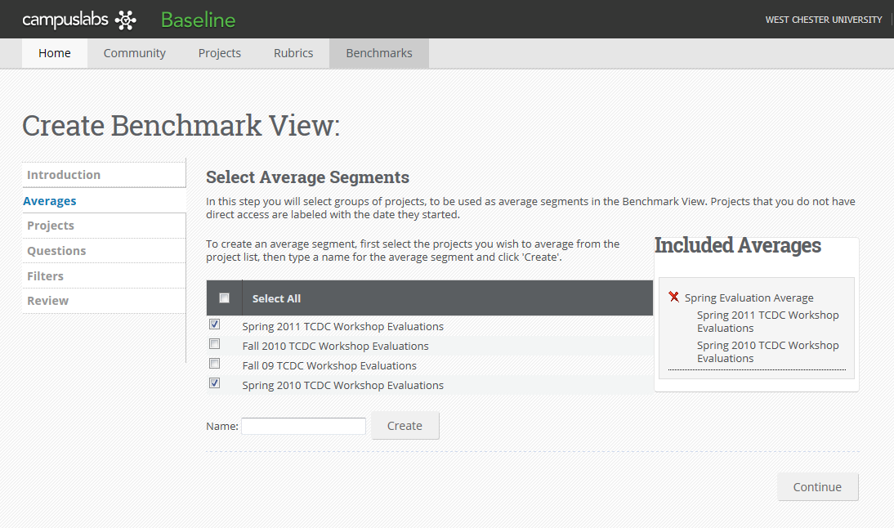
Click Continue to proceed.

The Select Project Segments screen now lets you pick the projects you want to include in the comparison report (to compared with each other and against the average score).

Click on the green plus sign to add a project. TIP: Click on the projects in the order you wish for them to appear from top to bottom in your charts.
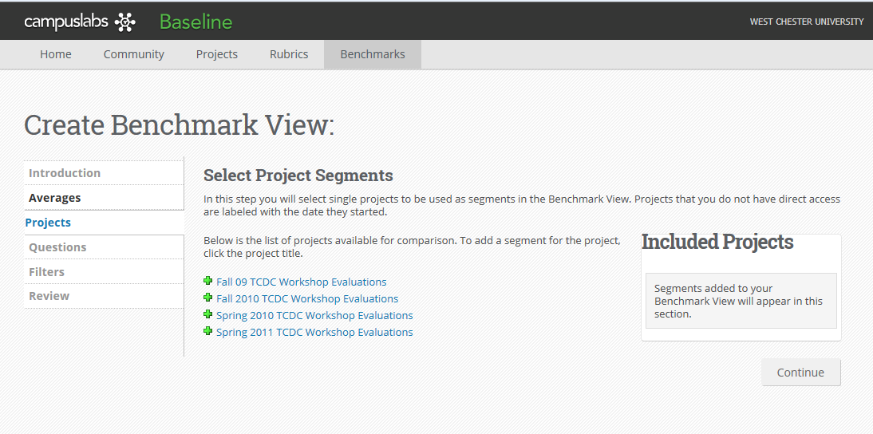

I clicked on Spring 2011 first so it appears first, followed by Spring 2010:
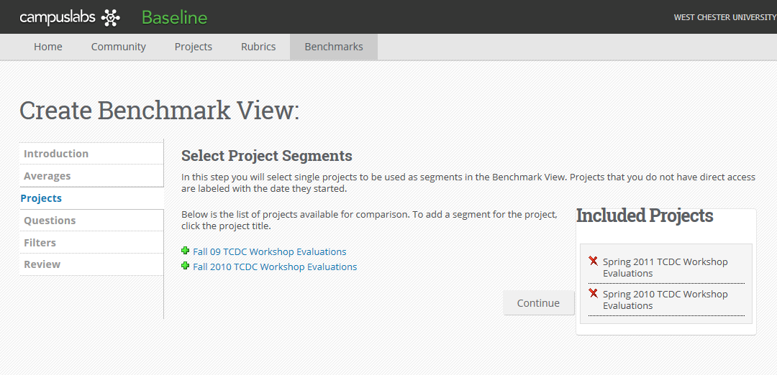

Click Continue

Select the questions you wish to compare then click Continue. If you have multiple surveys but one year you did not include one particular question – you can still benchmark compare the other projects, the final report will just not include a score for that question in that particular year in the final report.
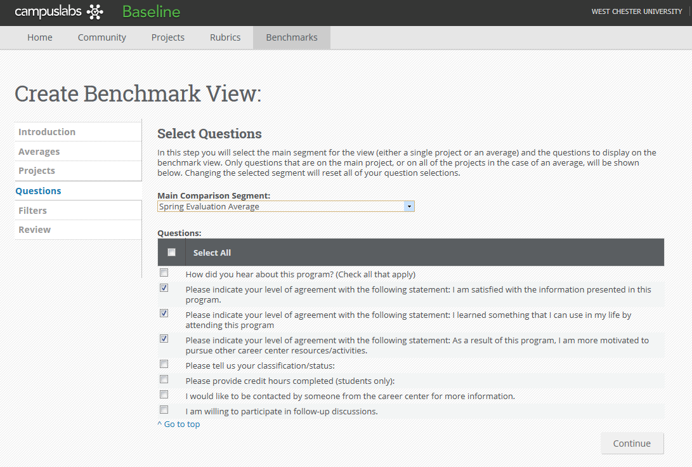

You may choose to filter your report according to responses from other questions. For example, if you ask for the students’ class year, you could potentially filter to see only juniors’ responses. You can also skip this and apply no filters.
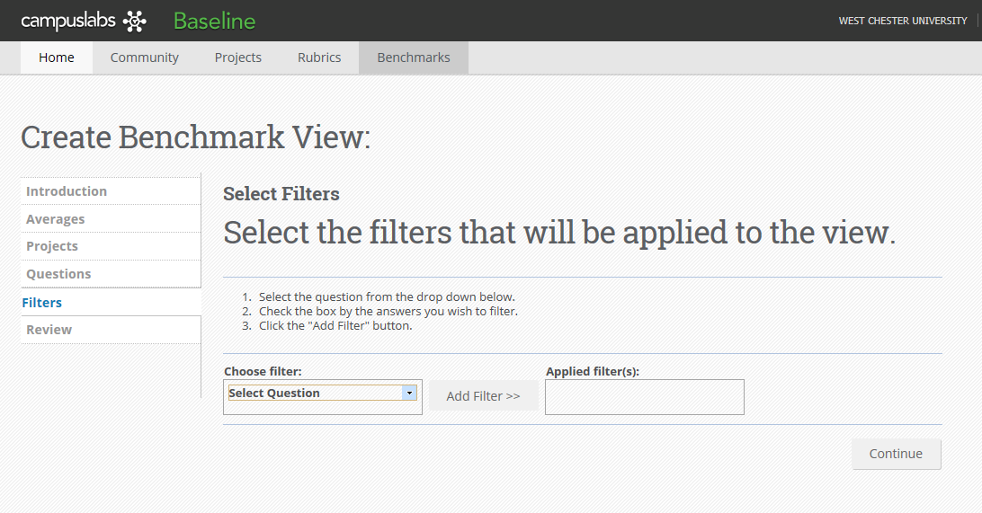

On the Review screen you can review all of your report selections (click the + symbol to expand each selection) as well as create the NAME for the report:

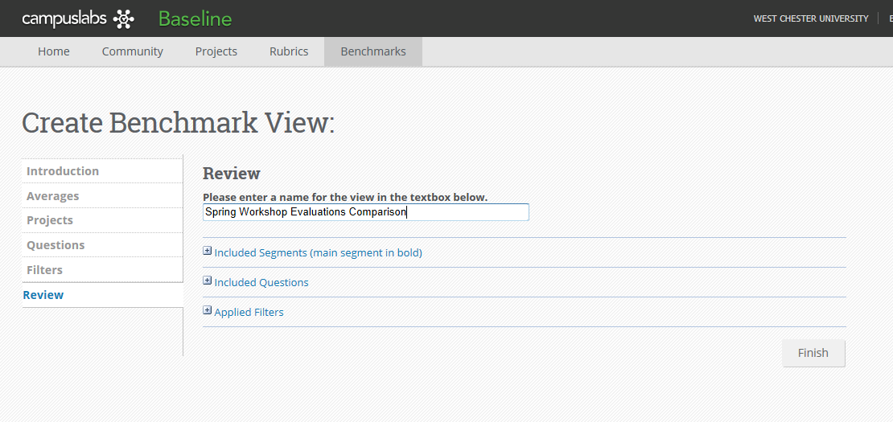

Click Finish to see the final report.

The report that is generated shows you the multi-project comparisons along with the average.
The title at the top of the report is the “Review” name you just created on the previous screen.

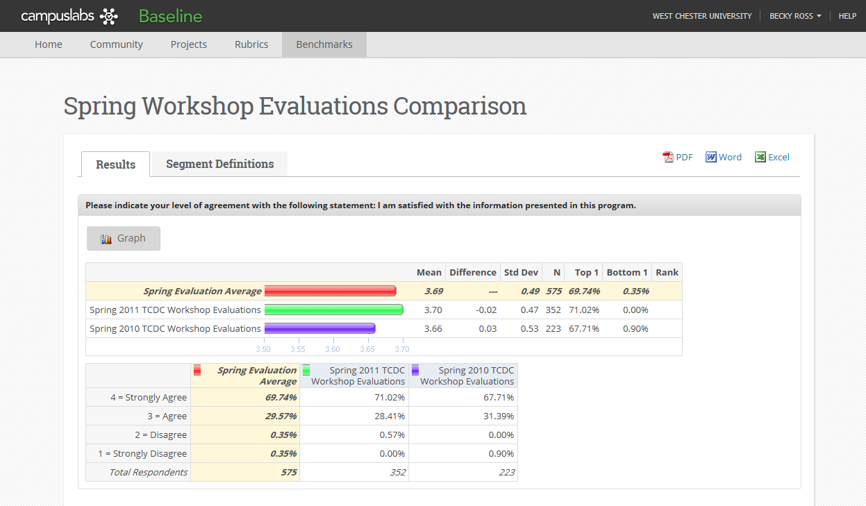

The top bar in the chart in red shows you the two-year average score. It also shows you whether there is or is not a statistically significant difference in the score comparisons (usually noted with asterisks).

Under the average segment, the individual project scores (in green and purple above) are presented. Note that these appear in the order that you selected them on the “Select Segments” screen.

You also get a summary comparison of how individuals responded to each individual item according to whatever rating or response scale was used.

