Checklist for Creating Accelerated Program Proposals
- Log into CIM-Programs (https://nextcatalog.wcupa.edu/programadmin/), and select the existing undergraduate degree that you want to add an accelerated option to.
  - (Note: You will not be adding a new program; you will be editing your existing undergraduate program.)
- Select the program and click Edit.
- In the Program/Change Summary field, add a note to “Add an Accelerated Program.”
- You’ll add the accelerated curriculum beneath the existing undergraduate curriculum, in the Program Curriculum/Advising Sheet field (shown in the screenshot below).
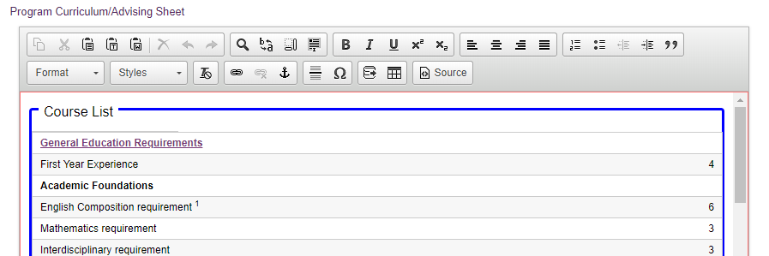
- Scroll down past the program’s current undergraduate curriculum and add a heading describing the accelerated program, following this format: “Accelerated B.S. in Criminal Justice to M.S. in Criminal Justice Program.”
- If there are any admissions or application requirements or policies above the standard accelerated policy, those should be listed next.
- Then click the Insert/Edit Formatted Table button highlighted in the screenshot below.
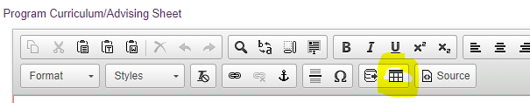

- Select type: Course List and click Ok.
- If this is the first time you are creating a curriculum table, you should review the CIM-Basic Program Training Guide or the Curriculum Building training video found here: https://wcupa.sharepoint.com/sites/AA/capc/CIM/Forms/AllItems.aspx
- Double-check that graduate courses mapped into the undergraduate curriculum do not exceed 40% of the total credits for the graduate degree. Review all Accelerated Programs Policies.
- Upload the program assessment as an attachment if graduate courses are being substituted for undergraduate major requirements.
  - (Note: A plan is not needed if the graduate courses are used for electives only. The plan will be reviewed to assure student learning outcomes for both the undergraduate and graduate degrees are being met.)
- Upload an advising sheet that includes bachelors through master’s degree requirements.
- If the graduate program is in a separate department from the undergraduate program, gather and upload statements of support from the department chair and college dean from the graduate program.
Sample Accelerated Programs
- A list of accelerated programs can be found in the Undergraduate Catalog: https://catalog.wcupa.edu/undergraduate/accelerated-programs/
- Search an individual program in CIM-Programs to view the program’s accelerated proposal that was approved by CAPC.

