
220 E. Rosedale Avenue

Built: 1976 | Size: 11,716 sf
Acquired: 1995 | Condition: Excellent
Last Renovation: 1998 | Function: E&G

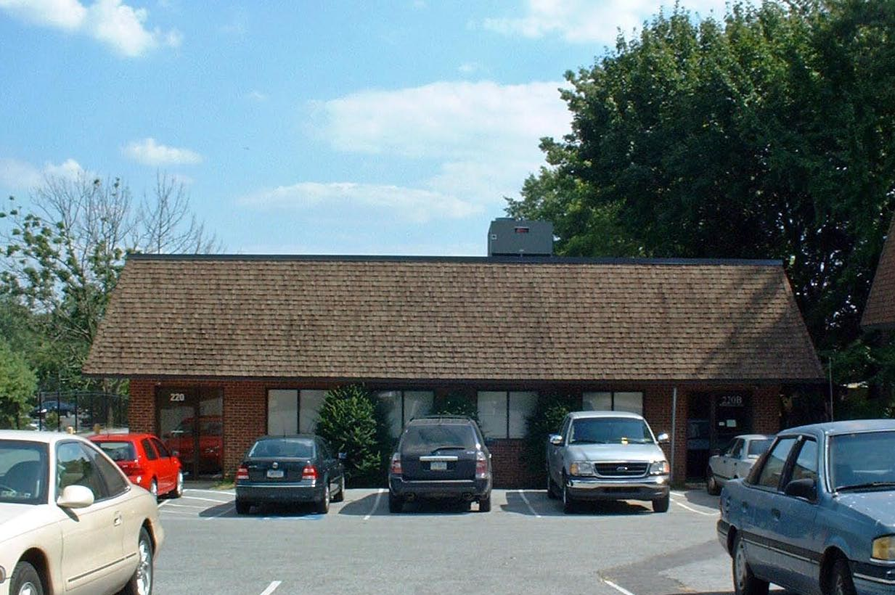

220 E. Rosedale has been renovated to accommodate the Equine Toxicology Laboratory.

Present Use: Equine Toxicology Laboratory- leased to PA Department of Agriculture.

Disability Access: Full

Past Projects: 1998 General Renovation, Roof; 2007- expanded Laboratory into former flex space.

Scheduled Projects or Capital Renovations: N/A

Description of Construction: Concrete and cinder block foundation, concrete floor, cinder block walls, composition shingle roof.

Condition and Use Assessment:
Deferred Maintenance (2007): $ 0 | Est Replacement Cost (2007): $ 3,155,000
Facility Condition Index: 0. | Deficiency/SF: $ 0
Yearly Electric Use Cost: $ | Yearly Water Use Cost $

