How To Review Personnel Budget Transfers via the Campus BI Report
Select Year, EG Fund (7511) Hierarchy and Fund Centers (by division or by individual fund center). The Report Lists all budget transfers by SAP Document date and number.
1. Select the Campus BI Budget Report within the Campus Reports Option:
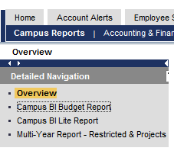
2. Enter the following information on the Variable Screen:
A. Fiscal Year (i.e. 2016)
B. Fund Center for the entire Division via Predefined Groups * or Single/Multiple Option
C. Fund Type Hierarchy**- Selection of EG fund transfers only (see screen shot)
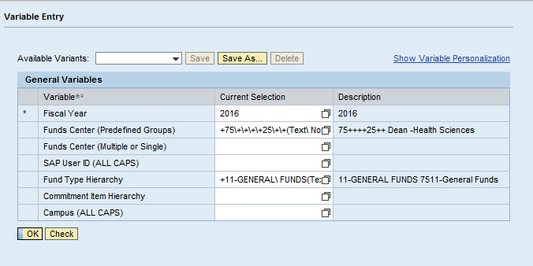

Then Select Ok
* & ** See Screen Shot examples below

*Predefined Fund Center Groups – Select for All Divisional Transfers ->highlight selection -> Add-> OK 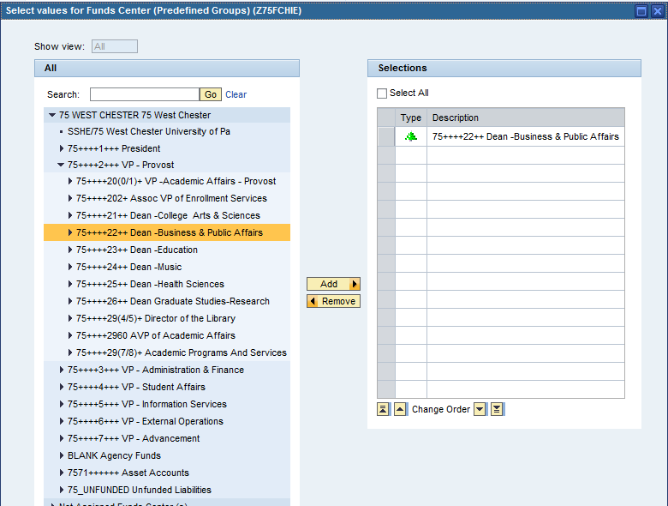
** Fund Type Heirarchy Selection – Expand E&G Funds 751 -> then 11- General Funds->Add-> OK
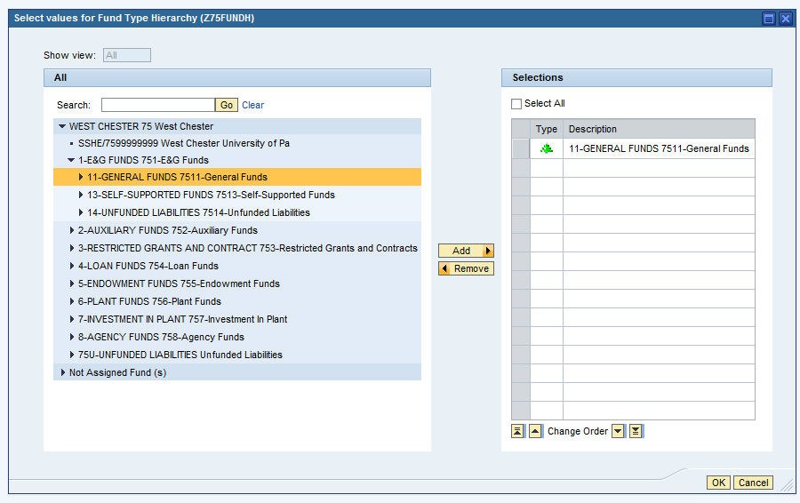

3. The BI Report Defaults to the Balances tab:

A. Select the Budget tab.

B . Then Select the Personnel Budget Transfers (EG non Base) within the drop down.

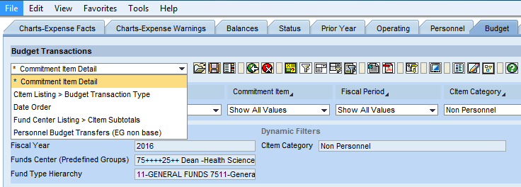

4. Resulting Report- lists all SAP budget transfers posted by date within the fiscal year selected.

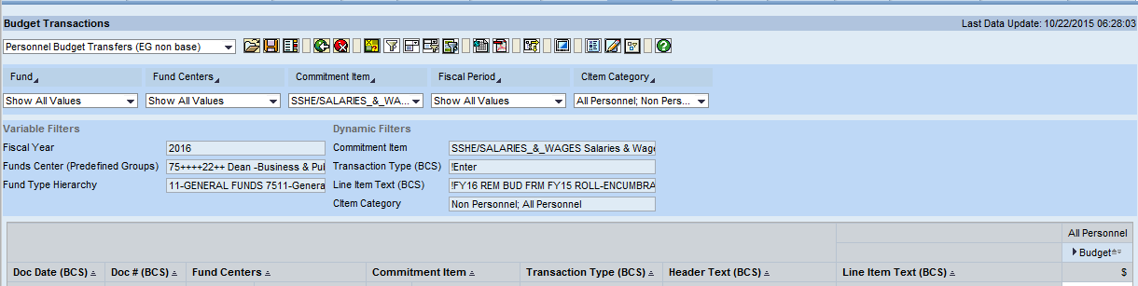

5. Export into Excel via the Icon on the Tool Bar.

