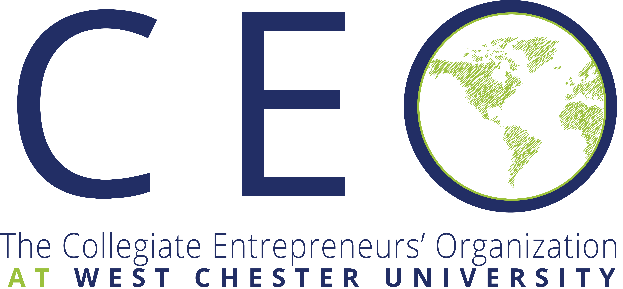
“share, innovate, create”

CEO’s Mission
To inform, support and inspire college students to be entrepreneurial and seek opportunity through enterprise creation. With a diverse entrepreneurial community and global network, CEO provides student entrepreneurs with opportunities, events, chapter activities and conferences to help start businesses. The highlight of the year is the annual Global Conference hosted each fall.

CEO’s Vision
To serve more than 400 colleges and universities helping students achieve their entrepreneurial dreams and goals. CEO provides student entrepreneurs with opportunities, events, chapter activities and conferences to help start businesses.

Benefits OF CEO at WCU
- Access to a network of global/national collegiate entrepreneurs
- Access to live webinar's featuring successful entrepreneurs
- The Collegiate Entrepreneur newsletter, published quarterly and online
- Chapter speakers, business start-ups, teaching entrepreneurship, internships
- Discounted registration fees to the Global CEO Conference
- Communication on entrepreneurial challenges through the CEO online Social Networking Community
- Student entrepreneur competitions, including the elevator pitch at the national conference
- Chapter development support
- Leadership training
- Discounts on products and services
- Chapter awards
- Membership fee of $25
Contact Information
Yasmiyn Hackney, CEO WCU President, YI779172@wcupa.edu
Dr. Edwin Cottrell Entrepreneurial Leadership Center
318 Business and Public Management Center
www.wcupa.edu/cottrellcenter

