**ANALYSIS OF THE SIMPLFIED GRODINS MODEL OF RESPIRATION**

P. Kumar

submitted: May 6, 2015

The Simplified Grodins Model gives a quantitatively accurate representation of human respiration by taking into account factors such as metabolic rate of different body systems, as well as a response-control system reacting to the partial pressures of CO2 flowing through the system. After understanding the motivation behind this mathematical model, we go in-depth by analyzing solutions to the homogenous, non-homogenous, and semi-linear forms of this model. Our analysis leads to a conclusion that, quantitatively, the homogenous form models human respiration more accurately; though qualitatively the semi-linear model gives us the most realistic approach.

**I. INTRODUCTION**

As you read this paper you are most likely not gasping for air as you would after sprinting around a track, or catching your breath after asking out that special someone. But why is that? Sure, psychologically, emotions manifest as physical “ticks” in/from our bodies. But, biologically, our bodies react to homeostatic imbalance, for example, in the form of muscle contraction. Cellular respiration is required to supply energy for muscle contraction, and a resulting byproduct of this process is carbon dioxide (CO2). If receptors in the brain detect CO2 concentrations rising (due to rising blood pH levels), the brain will signal the diaphragm to increase contraction rate.

This system of gas-exchange between bodily systems has been examined extensively by Haldane in 1905, where they experimentally concluded that the primary agent causing increases in ventilation rate is CO2.1 Gray in 1946 tried to understand the “multiple factors” affecting this system.2 However, his theory, as pointed out by Grodins in 1967, was limited one forcing term, CO2 inhalation.3 We consider a simplified version of Grodins’s mathematical model of respiration, as presented in McKibben4 and Keener5, for this exposition.

Let’s begin with a simple three-compartment model composed of the lungs, brain, and soft tissue as their own system. Every quantity related to these systems, will have the subscript L, B, or T. The lungs provide a passage way for all gases, anything that enters the lungs, also disperses throughout the rest of the body (at least for the sake of our model). The brain, obviously, serves as the control system of the body. More specific to our model, the brain causes ventilation rate, , to increase if the CO2 concentration, *C*, in the blood increase. Lastly, soft tissue encompasses all other organs and systems of the body through which the gas propagates. A link or passageway (loosely modeling blood flow, which we denote *f*) from the lungs breaks into two passages; one towards the brain, with blood flow rate *fB*, and the other to the soft tissue, with blood flow rate *f-fB*. These passageways then recombine to lead blood from the brain and soft tissue back to the lungs. (See Figure 1.)

In order to simplify our model, we make the following assumptions4: (1) the concentration of CO2 leaving the brain and soft tissue is the same as the concentration of CO2 in those respective compartments. (2) We assume was that the concentration of CO2 entering the brain and soft tissue, were time-delayed versions of what left the lungs.

CB,o

CT,o

CT,i

*f-f*B

CB,i

*fB*

*f*

CL,o

CL,i

Lungs,

CL

Brain,

CB

Soft tissue,

CT

**Figure 1.** Compartment model for the analysis of the Simplified Grodins Model.

The CO2 that enters the lungs is a combination of time-delayed versions of what left the brain and soft tissue. However, we further assume that these time delays are zero. (3) Finally, the partial pressure of CO2 that leaves the body is the same as the one entering. We will refer to the respiration model, with these assumptions as the Simplified Grodins Model-I (SGM-I). These, with the assumption that the ventilation rate is fixed we’ll refer to as the Simplified Grodins Model-II (SGM-II).

From here we will derive a full mathematical description of these models, beginning with a model with no forcing term (homogenous case), then moving to a model with linear forcing terms (non-homogenous case), and finally, we examine a model with a non-linear forcing term (semi-linear case). While we could perform our analysis on the models using concentrations, we convert to partial pressures in the spirit of Grodins’s analysis in 1967.

**III. HOMOGENOUS CASE**

We use a simple “rate-in/rate-out” method to derive the homogenous SGM-II, to determine how the amount of CO2 in each compartment changes. We define *Vi,* to be the volume of compartment *i*. So, for the brain, the change in the amount of CO2 is given by the difference in flow rate in, *fBCB,i*(*t*), and flow rate out, -*fBCB,o*.

. (1)

From our assumptions, we know the concentration of CO2 going into the brain, is the same as what left the lungs. And we know the concentration of CO2 leaving the brain is the same as the concentration in the brain. Making these changes, along with converting concentrations to partial pressures,

, (2)

where  is a constant arising from converting concentrations to partial pressures.

Similarly, for the soft tissue we have,

,

(3)

Now we consider the partial pressure of CO2, leaving the lungs. To start our “rate-in/rate-out” method gives,

, (4)

Using the same assumptions, we rearrange the terms, to find

. (5)

If we take the partial pressure of the brain and soft tissue to be zero in equations (2), (3) and (5), we find a system of differential equations for the homogenous case, for which the initial conditions will be the initial partial pressures in each compartment;



(6)

This system, obviously, has no term forcing a change in the partial pressure flow rate. Essentially in this model we’re assuming whatever comes out of the lungs goes to the brain and lungs based on the respective blood flow, into those compartments.

We re-write the system as a vector equation;



, (7)

This system has a unique solution, by Theorem 4.6.1 from McKibben4, which is given by

, (8)

From McKibben4, we see that all solutions of this form (Homogenous Cauchy Problem or HCP, as it is referred), depend continuously on the initial data. If there were any error in the initial conditions, it would appear in the initial condition vector in (8). If any error arose in the flow rates and/or the volumes of each compartment, then they would appear in the exponential matrix. Either way, if the error were reduced to zero, the solutions would approach that of the form in (8).

An example solutions graph is shown in Figure 2. The solutions are sinusoidal, which makes sense for the simplified physiology because the obviously the CO2 partial pressures in one compartment cause an almost complementary change in another. Also, there is no damping, which makes sense, because this, again is modeling the CO2 flow for someone who may have a “sedentary-like” lifestyle.

**III. NON-HOMOGENEOUS CASE**

We now consider the SGM-II in the non-homogenous case; with linear forcing terms. Our forcing terms in this case will be the metabolic rates of the brain, *MB,* and soft tissue, *MT*. Before we took the partial pressure of the brain and soft tissue to be zero; here they some positive constant. We include the ventilation rate,  of the partial pressure of CO2, ,out of the system entirely.

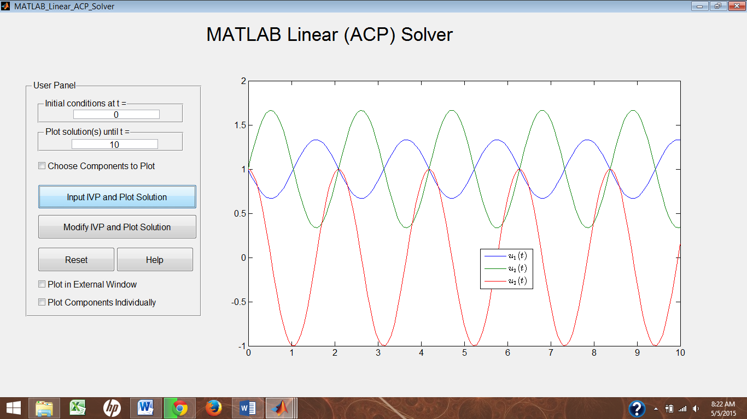

**Figure 2.** Example solutions graph for the homogeneous SGM-I. The sinusoidal behavior is due to the constant pressure of the isolated system circulating through the compartments.

The metabolic and ventilation rates are added to the equations of their respective compartments, in (6);



(9)

The metabolic rates, as the forcing terms, take into account the bodily conditions that dictate the way each system processes substances like carbohydrates, gases, and proteins. One condition it may take into account would be the “fitness level” of a person; a fit person will naturally have more efficient energy needs. (However, even fitness is dependent on how active the person is, and even more so how their diet is.) Ideally, these forcing terms will depend on these external factors, to have a more realistic respiration model. The metabolic rates may be constant or linear functions of *t*. Taking the idea of more efficient needs, mathematically the metabolic rate should serve to “linearize” the partial pressure solutions. For example, a sinusoidal change to the partial pressures instead becomes a “smooth” linear flow.

The inclusion of the ventilation rate is an attempt to more closely model an un-isolated respiratory system; since in reality there is no constant partial pressure coming out the lungs. The terms works to decrease the partial pressure of CO2 coming out of the lungs. Ventilation rate will serve to change the partial pressure of CO2 in each compartment. If the ventilation rate is high, then CO2 levels will go down; (If ventilation rate is low, then CO2 has a chance to build up in each compartment.)

The partial pressures of the brain and soft tissue having a positive value, takes into account that the brain and soft tissue indeed have an intrinsic CO2 partial pressure.

We re-write (9) as a vector equation;



(10)

which is of the form (Non-CP) as described by McKibben4. If we require the forcing term to be continuous, then by Theorem 5.3.1, from McKibben4, a unique solution exists, given by the technique of variation of parameters.4 That is, the solution is



(11)

Using MATLAB, we show an example solution plot for this non-homogeneous case, in Figure 3. While the partial pressure leaving the lungs levels off, the partial pressures in the brain and soft tissue are constantly growing. This doesn’t seem to make any physical sense since partial pressures cannot increase indefinitely. Changing parameters according to physical reality, only seems the change the periodicity of the solution for the partial pressures of the brain and soft tissue; no effect on the over-arching increasing behavior.

Figure 4 has the same parameters as the graph in Figure 3, except the metabolic rate has been reduced by a factor of 500, and the solutions for all compartments approach a steady-state. So, we conjecture that as we reduce the metabolic rate, the partial pressures of CO2 approach a constant level. However, this contradicts our original hypothesis that an increase in the metabolic rate should serve to make energy needs more efficient. More examination is required on this matter.

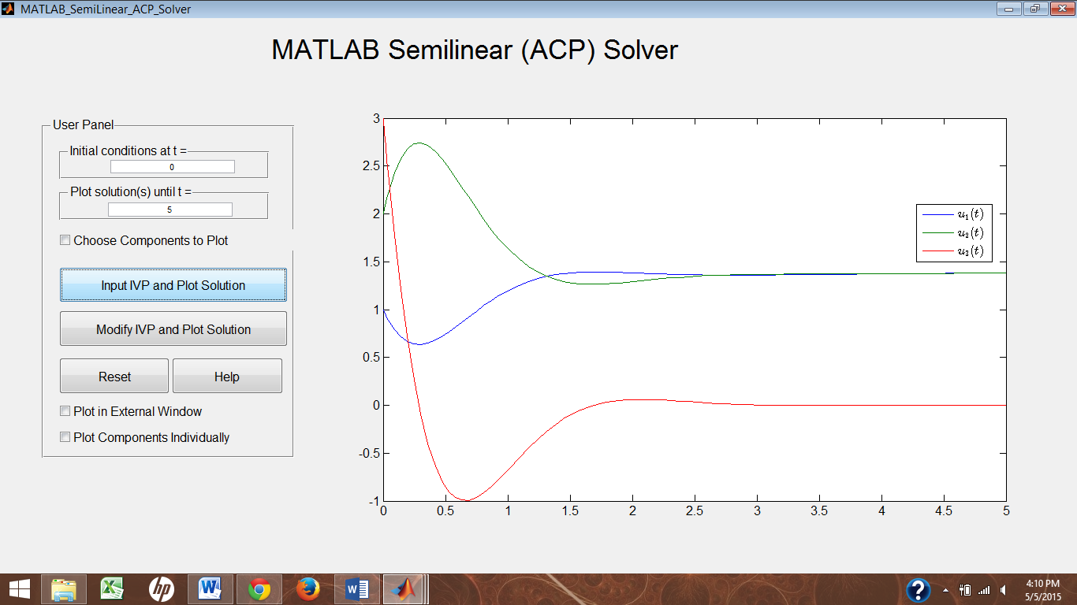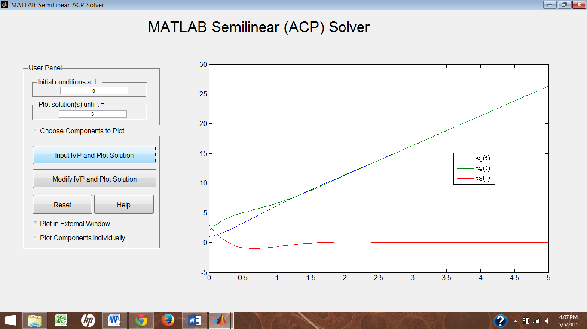

**Figure 3.** Example solution plot of non-homogeneous SGM-II, with a forcing vector (5,5,0).

**Figure 4.** Example solution of the non-homogeneous SGM-II, with a forcing vector of (0.01,0.01,0)

**III. SEMI-LINEAR CASE**

We now consider the non-homogenous model given by (9), now with a non-constant ventilation rate, the form of which is given by McKibben4 (i.e. SGM-II);



(12)

where  is the base ventilation rate, *k*  is the rate of increase as the brain detects an excess CO2 partial pressure, and is the CO2 partial pressure threshold for the brain.

This model takes into account the response-control set up by the nervous system. That is, as the CO2 partial pressure is increased in the blood, this will cause the partial pressure in the brain to rise, to above a certain threshold, at which the ventilation rate is increased to expel CO2 from the system.

If we re-write this as a vector equation, we find



(13)

By Theorem 7.6.1 from McKibben4, we impose the condition that the forcing vector be continuous and Lipschitz for this to have a solution, given by the variation of parameters formula as



(14)

This solution very closely resembles the solution for the non-homogenous respiration model. In the non-homogenous case, the exponential matrix had a term to account for constant ventilation. Since in the semi-linear case we claim the ventilation rate as a function of time, this becomes a constituent of the forcing vector, because it behaves like a product of the function of CO2 partial pressure in the brain with that of the soft tissue. Because of this similarity, we believe this semi-linear solution to be similar to the non-homogenous solution. In fact, in Figure 5 the graph has the same parameters as Figure 3, except the matrix and forcing vector were adjusted for the semi-linear case; product of *PB*(*t*)*PL,out*(*t*) was used for the third component of the forcing vector. The solutions are very similar if not exactly the same.

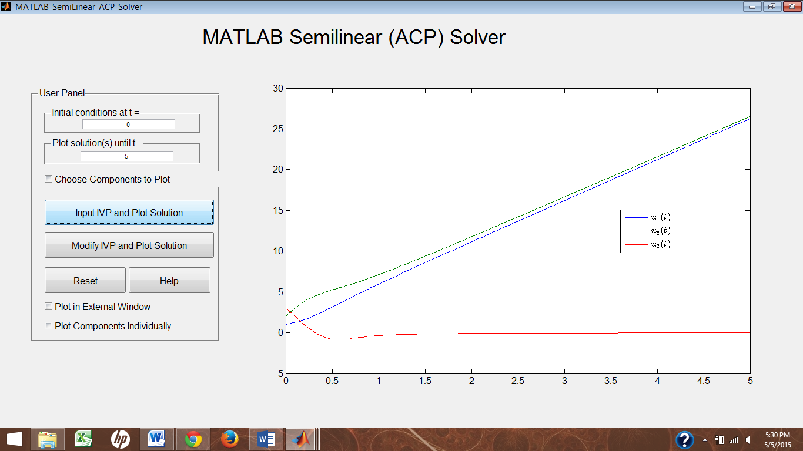The ventilation rate slope was observed to shift between sinusoidal and linear solutions, which is observed in the graph of

**Figure 5.** Solution plot of semi-linear SGM-I.

Figure 6, which has the same parameters as the graph in Figure 5, except a factor of 200 less in the slope of the ventilation rate.

**IV. CONCLUSION**

Based on our analysis of homogenous, non-homogenous, and semi-linear Simplified Grodins Model of respiratory partial pressures, we are led to conclude that the homogeneous case gives us a more accurate model than the other two. Non-homogenous and semi-linear give us a fairly reasonable model for the partial pressures of CO2 coming out of the lungs, but not the partial pressures of the brain and soft tissue. Though theoretically, the semi-linear model gives a more realistic approach. Further examination of the terms of the matrix exponential and forcing vector, is required.

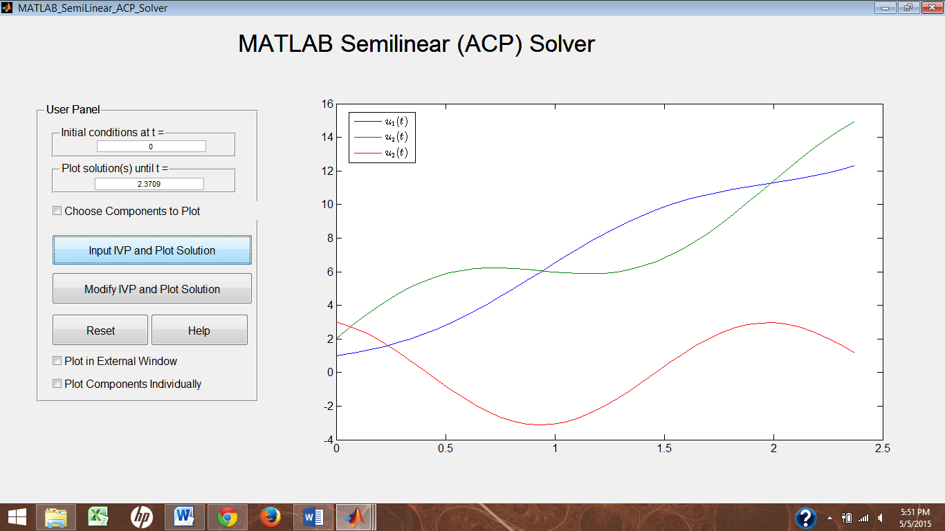

**V. REFERENCES**

**Figure 6.** Solution plot of semi-linear SGM-II, with the same parameters as the solution plotted in Figure 5, except the ventilation rate here is reduced by a factor of 200.

[1] J. S. Haldane, and J. G. Priestley. *The Regulation of Lung-Ventilation.* The Journal of Physiology, 32, 225–266. (1905).

[2] J. S. Gray. *The Multiple Factory Theory of the Control of Respiratory Ventilation.* American Association for the Advancement of Science, 103, 739–744, (1946).

[3] F. S. Grodins, J. Buell, A. Bart. *Mathematical analysis and digital simulation of the respiratory control system.* J. Appl. Physiol., 22(2), 260–276, (1967).

[4] M. A. McKibben and M. D. Webster. *Differential Equations with MATLAB: Exploration, Application, and Theory.* CRC Press. (2015).

[5] J. Keener and J. Sneyd. *Mathematical Physiology II: Systems Physiology.* Springer. (2009).