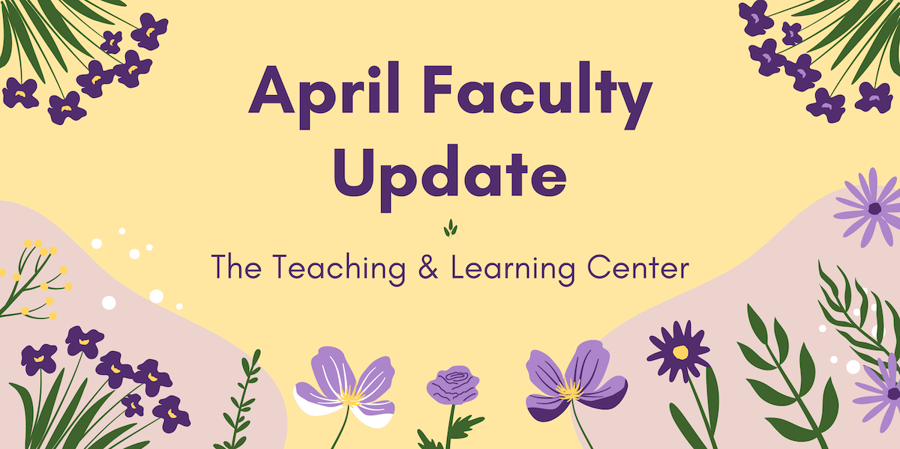

Open Initiatives

Spring 2024 Adjunct Faculty Cohort Mentoring Program
Join seasoned adjunct faculty mentors for discussion and Q&A discussing professional development related to teaching, scholarship, and service, and as a bonus, build your community at WCU! Sign up online to meet with a faculty mentor during a convenient one-hour time slot over Zoom this March and/or April.

All adjunct faculty are invited to join the program. Additional details can be found on the Spring 2024 Adjunct Faculty Mentoring flyer, and any questions can be directed to Innhwa Park (ipark@wcupa.edu), Yanan Chen (ychen@wcupa.edu), Laura Fiorenza (lfiorenza@wcupa.edu), or Vipanchi Mishra (vmishra@wcupa.edu).

Upcoming Events & Workshops

Indigenous Identities: Anti-colonial Pedagogy and Native American Inclusivity
Join our Diversity & Inclusion Faculty Learning Community on Thursday, April 11 at 5:30pm for a free webinar featuring Dr. Joseph Miller, Assistant Professor of Philosophy. Dr. Miller is an Assistant Professor in the Philosophy Department at West Chester University. He is an enrolled member of Muscogee Nation of Oklahoma, and his research interests include Native American ethical frameworks and the pedagogical legacies of Native American boarding schools. Register today!

Proactive Accessibility: Minimizing Accommodation Requests through Inclusive Course Design
Have you noticed an increase in student requests for accommodations in your courses? You’re not alone! Join the OEA and the TLC on Thursday, April 25 at 2:00pm for a workshop to explore effective strategies for supporting students with diverse learning needs and designing courses that minimize the need for individual student accommodations. This workshop is co-sponsored by the Faculty Ombuds Office. Register for the Proactive Accessibility workshop today!

Generative AI Webinars
Enhance your Generative AI literacy by attending a TLC AI webinar! These hour-long Zoom sessions start with a brief overview of a generative AI tool, spend 30 minutes on the session’s topic, and end with time for questions and conversation.
Our last webinar for the semester will be Enhancing Your Productivity with Generative AI, held on Thursday, April 25 at 12:30pm. Register today, or if you can't attend, check out the recording on our blog the week after the event.

Celebration of Teaching
Incredible teaching happens every day across WCU! Join us on Tuesday, May 7 for a series of four events to sample and discover new WCU teaching innovations, dialog with peers on teaching topics, and celebrate the teaching excellence that happens across WCU. The day's events will include mini-workshops, our 9th annual Teaching Excellence Showcase, a virtual keynote presentation, and the TLC Teaching Awards Ceremony. Register now or check out our blog for more information! We hope to see you there!

RECAP Conference
Join us at the 29th Annual RECAP Conference on Thursday, May 16 for a day of inspiration, knowledge exchange, and networking! Hosted by Information Services & Technology in partnership with the TLC, this event promises to be a showcase of reliable strategies, transformative technologies, and innovative pedagogical approaches that are shaping the future of higher education.
To learn more, visit the RECAP site, or register for RECAP today!

Applying the Quality Matters Rubric (APPQMR) Training
This full day, in-person workshop will renew your CAPC Distance Education Training Credential and award you the official Quality Matters APPQMR Certificate of Completion. It is facilitated by WCU instructional designers. The training will be held on Wednesday, May 15 from 8:30am to 4:00pm; participants must attend the whole day. Complete the APPQMR Interest Form, and a member of the TLC will be in contact a few weeks prior to the workshop.

Program Updates

Classroom Technology Survey
What are your experiences using classroom technology for teaching? The TLC and IS&T want to hear from you! We invite you to take this brief survey to share your experiences, preferences and needs regarding classroom technology for teaching. The survey should take you about 15 – 20 minutes to complete. Findings from the survey will inform the development of resources and programs to support you. Please complete the survey by Monday, April 29.

Online Faculty Development Program
Need to earn or renew your CAPC distance education credential? Faculty can now self-enroll into the OFD program’s D2L site using the Discover feature! Start working whenever it fits your schedule.

Stay Connected

ODLI on Air Podcast
Last month, we learned from Biology professor and amateur livestreamer, Michael Rosario, about one alternative to Zoom meetings for class and heard the story of how our science building was renamed from the student activists themselves! For more conversations and stories from around campus, check out our back catalog or subscribe to see what's next.

Connect with Us
The Teaching and Learning Center is far more than just a newsletter! Our website hosts a variety of teaching resources and our full Event Calendar. To get in touch, feel free to send us an email, or stop by our drop-in hours to speak live with one of our designers.

